An Evaluation of the Influence of Haptic Feedback on Gaze

Car display Record sight Tactile feedback

【Main Content】:

Effects of haptic feedback on task performance and gaze behavior during simulated car driving

【Several hypothesis】:

**H1:** Eyes-free touch screen interaction is possible with haptic feedback

**H2:** When haptic feedback is added to visual feedback,driver distraction is reduced, compared to when only visual feedback is provided.

**H3:** When both visual and haptic feedback are available, subjects rely less on the haptic channel, compared to the when only haptic feedback is provided.

**H4:** When subjects experience the haptic feedback condition first, they are more willing to rely on the haptic channel in the combined visual-haptic condition.

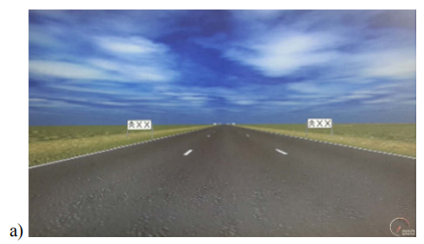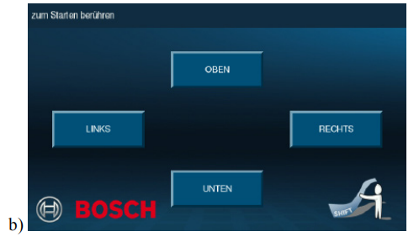

【Experiments】：

**Task 1:** In the driving task, participants performed the lane change task (LCT, see Fig. 2a), a standardized lab based method to quantify driving performance degradation caused by a secondary task (ISO 260222, 2010). In the LCT, subjects drive at a constant speed of 60 km/h on a straight, three-lane road. No other cars are present on the road at all time. Subjects are instructed to change lanes as fast and accurate as possible as soon as a sign on each side of the road indicates to do so. The target lane information appears 40 meters ahead of the signs. An LCT track takes three minutes to complete and requires 18 lane changes.

**Task 2:** In the secondary task, participants had to press one out of four buttons located at the left, right, top and bottom side of the graphical user interface (see Fig. 2b). The target button was announced with a recorded spoken command via the loud speaker. Subjects were asked to select the button within 7 seconds after the initial announcement, and move their hand back to the steering wheel afterwards. Multiple corrections were possible within these 7 seconds. The response time was not measured. The next target button was announced after a random interval ranging between 8 and 10 seconds after the previous target button announcement, irrespective of whether the correct or the wrong button was selected by the subject One trial consisted of 21 randomized button press tasks, where each button location was defined as target at least 5 times. The secondary task was started manually by the experimenter at a specific visual landmark in den driving task to ensure that both tasks were roughly synchronized.

**Four experimental metrics:**

Secondary task performance

Driving performance

Gaze behavior

Mental effort

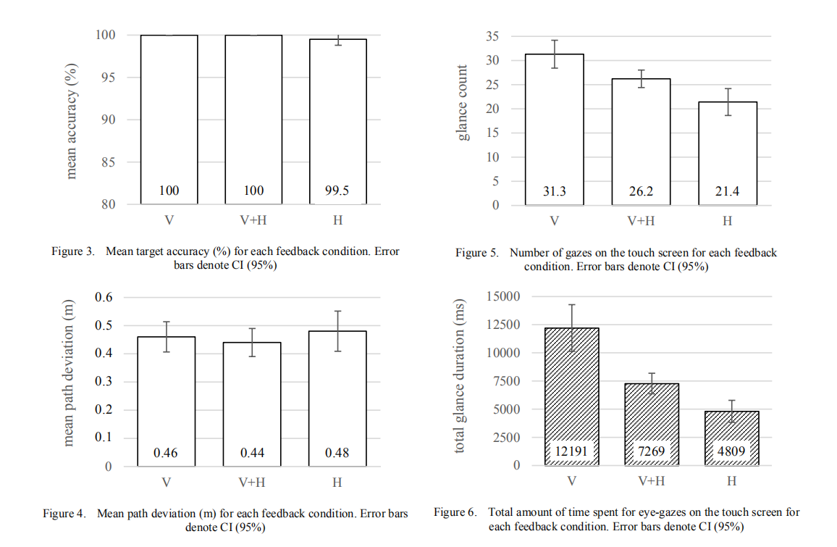

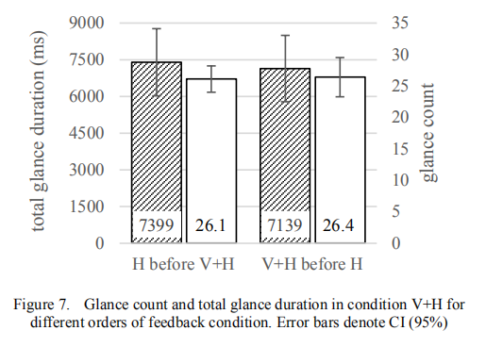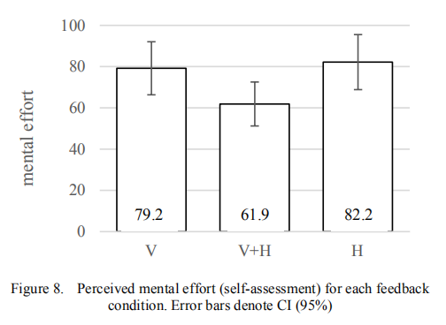

Data analysis: see the paper for specific analysis

conclusion:

1)

             Support H1 H3

             Reject H2 H4

2) In touch screen interaction, additional tactile feedback is beneficial

3) Although complete eyeless screen interactions are occasionally found in individual missions, most drivers still initially look at the touchscreen

【Future Work】:

Compared to our lab environment, the most realistic car dashboards still contain graspable elements (such as the sensible edges of an embedded touch screen) that can serve as reference points and may further reduce these initial glances. We plan to conduct further research in the future to investigate this.

【Subjective analysis】:

**Advantage:**

In the simulated driving environment, a series of evaluations and hypothetical verifications of haptic feedback were performed. Finally, it is concluded that: 1) driver's eyeless touch screen interaction can be achieved through haptic feedback 2) when both visual and haptic feedback are available, compared with the case where only haptic feedback is provided, the subject has less dependence on the haptic channel.

**Disadvantages:**

1. Emulated the settings of button edge touch and click touch in [Deriving User Requirements for Haptic Enhanced Automotive Touch Screen Interaction], but changed the former's tactile feedback
2. At the same time, there is no research on the layout and size of the buttons

【Important Reference】:

[1] A. Schmidt, A.K. Dey, A.L. Kun and W. Spiessl, "Automotive user interfaces: human computer interaction in the car." CHI'10 Extended Abstracts on Human Factors in Computing Systems. ACM, 2010

[2] M.J. Pitts, M.A. Williams, T. Wellings and A. Attridge, "Assessing subjective response to haptic feedback in automotive touchscreens." Proceedings of the 1st international Conference on Automotive User interfaces and interactive Vehicular Applications. ACM, 2009

[4] S. Zimmermann, S. Rümelin and A. Butz, "I feel it in my fingers: haptic guidance on touch surfaces." Proceedings of the 8th International Conference on Tangible, Embedded and Embodied Interaction. ACM, 2014

[5] M.J. Pitts, L. Skrypchuk, T. Wellings, A. Attridge and M.A. Williams, “Evaluating User Response to In-Car Haptic Feedback Touchscreens Using the Lane Change Test,” Advances in Human-Computer Interaction, vol. 2012, no. 2, 2012